Guidance for Parents and Pupils returning to school in September

Who am I?

I am Mrs Wardle, Behaviour and Pastoral Assistant at Cavendish Primary School. I am based in The Bridge and will be available across the school to work with pupils that are finding the return to school difficult.
I understand how uncertain most pupils and parents are about the return to school and it is my focus for the new academic year to ensure that all of our pupils are happy, settled and listened to when they return.
I am hoping that this Guidance will help to answer any questions you may have about the return to school and that this will help you to feel more relaxed about returning in the new year. If you have any worries or questions that you would like answered, please email me on wellbeing@cavendish.e-sussex.sch.uk

Anxiety is defined as a feeling of worry, nervousness, or unease about something with an uncertain outcome. Most of us will feel anxious about something that we have no control over and at the moment we are in a prolonged period of uncertainty. There are no definitive answers to anything and our children are more uncertain than ever, thus manifesting in feelings of uncertainly leading to anxiety.
Understandably there will be concerns about returning to school and how this will look and feel. As we approach the summer it is only normal for families to want to take a break from everything and just relax, but I would like to urge you to try and keep some routine just to ensure that the transition back to school after the summer is less stressful.
I would ask that every day, you have a simple morning routine of getting up, getting dressed, having breakfast and then an activity, whether it be a walk or bike ride or anything at all active. The idea for some children of putting on shoes and school clothes is almost unthinkable at the moment, so we need to be taking steps to alleviate any anxiety that could be building and ensure that the transition back into school is a calm and positive one. Being supportive and using positive praise will help to alleviate any worries that may arise.
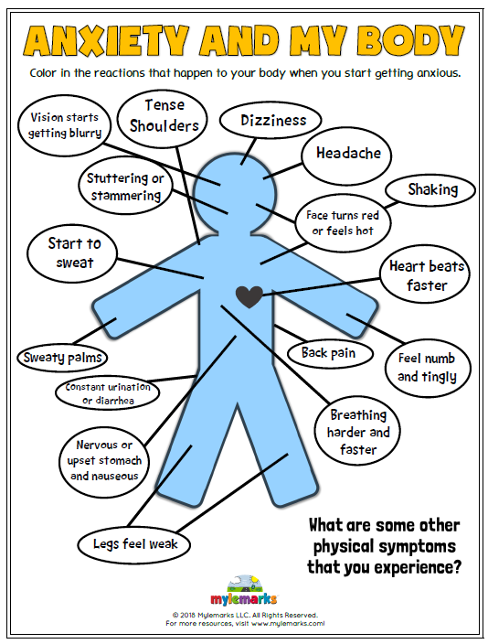
Please discuss the fact that things will be different to the time they were last in school. This is to be expected, but we are very focussed on ensuring that our pupils are supported and have access to alternative support when needed. I will be available to pupils that need a bit of time out of class if it all feels a bit too much, we will be able to access our allotments which are outside and can be a lovely environment for having chats and talking about any worries that arise. My focus moving forward will be very centred around wellbeing and all our pupils feeling supported and understood. Below is an image of how anxiety may manifest in a body.

The reasons for anxiety can be baffling to friends and family and it is not always easy to know how to help. For those who struggle, the experience can be overwhelming; children can become trapped in a cycle of avoidance, feeling like they simply can’t cope with school life.
Anxiety affects people in very different ways. Some may find it hard to sleep, eat or concentrate whilst others find that they just can’t stop themselves from thinking and worrying about the situation they fear, which can then get in the way of everyday life.
It is of course normal to feel anxious around things like exams, rollercoaster rides, a presentation, a visit to the dentist or anything that takes you out of your comfort zone and which people may find stressful, there are body changes associated with these feelings;
- Increased heart rate
- Butterflies in the stomach
- Sweaty palms
- Dry mouth resulting in confused words
This is the body’s ancient way of preparing physically for perceived threat or fear. Anxiety occurs when the level of threat is over-estimated and experienced as pervasive. As parents, your role in helping your child to manage their anxiety is essential and research shows that the right parental support can have very positive impact. Although all situations are unique, I will highlight a few ideas that may help when supporting your anxious child.
Empathise and Encourage
It is important to let your child know that overcoming anxiety is hard and that you are proud of their efforts. A good message to send is; “I know you’re scared and that is okay, I am here for you, I am going to help you get through this.” Help your child to understand that their feelings of worry, fear or anxiety are valid and that with the right tools, they can learn to manage and cope with whatever comes their way. Every time a fear is confronted is a success and the more successes your child accrues in dealing with their worries, the greater their confidence and eventually their resilience will be.
Don’t avoid everything that causes anxiety
Avoiding situations that make your child upset is a natural parental response, but in the long run this only serves to reinforce that anxiety. If you repeatedly remove your child from a situation that makes them anxious, they will start to learn this as a coping strategy and this can become a repeating cycle. An alternative method is to try an exposure ladder. This is where you and your child break down their anxiety into manageable steps and gradually increase these steps with the purpose of overcoming the anxiety. Developing a daily routine in preparation for school in September will help with alleviating the inevitable anxiousness but will ensure a smooth transition back to school, it is important to be in school so that we can continue the work of minimising the anxiety.
Don’t ask leading questions
While it is important to encourage your child to talk about their anxiety, asking leading questions should be avoided as this can reinforce their worries and validate their anxiety. For example you could ask them “How are you feeling about returning to school?” rather than “Are you worried about returning to school?”

Calm parent, calm child
Children learn their parent’s behaviours and so it is important to consider how your own anxiety can affect your child. If you are anxious or worried about something, your child will pick up on this and experience and increase in their own anxiety. So, in order to minimise your child’s anxiety, it is vital to be able to manage your own first. Communicate with your child when you are using a coping strategy; “I’m feeling a little bit nervous about this, so I am going to take a few deep breaths before I deal with it!” By modelling appropriate behaviour and positive thinking, you will empower your child to look for the positives in situations as well. This can lead to a minimising of the anxiety being felt.
Reduce the amount of time your child has to anticipate a given event
Often the hardest part for children who are anxious is the run up to the anxious event or act. It is therefore very important for you to try and eliminate the period of anticipation or at least try and keep it to a minimum.
Support your child in confronting fears (where possible)
It is through this exploration that your child will learn the coping skills required to overcome their worries and anxieties. Ensure that you are consistent in encouraging your child to come to school and to maintain good attendance while still supporting any concerns they may have. Avoiding worries and fears is far easier than confronting them for your child in the short term, but can lead to them learning how to “stay off” school. Avoiding these worries can lead to school avoidance and refusal in the long term. This can become incredibly hard to break. Confront rather than avoid, we will do all that we can as a school to support you and your child.
Prepare for return and introduce routine
Ensure that you establish and maintain healthy routines during the summer. To include eating, sleep and exercise). Sleep patterns are particularly important, getting good sleep is vital to feeling good and positive the following day. Poor sleep patterns can feed anxiety and sleeping during the day will just make it more difficult to break a cycle of avoidance. When you are preparing for the start of the school year, encourage your child to follow a good routine and prepare for the following day the night before so that in the morning, there is no added rush which limits opportunities for excuses and delays.
It is important to enjoy the summer holidays and make the most of the free time before school begins, but it is also vital to keep talking to your child about any concerns they may have and try to support your child to minimise these by focussing on the familiar things that they can control to help them feel more confident and secure moving forward.
If you haven’t already tried then maybe practising mindfulness could be helpful for you, starting with short guided meditations could be helpful. Try doing things together and talking through the return to school to alleviate any fears or worries your child may have.
I would like to highlight a few things your child can try to help alleviating any anxiety they may have. It is not advisable to do all of them at once, but perhaps choose two or three that you think may be helpful to you;
Talk to someone they trust. Talking to someone about how they are feeling can be very helpful, this could be a family member, friend or someone at school. By doing this you will notice that you are not the only person experiencing these feelings and adults are able to help you in many ways when they know how you are feeling.
Try out some relaxation techniques. I have found a helpful video on Youtube which is a gentle guided meditation, click HERE to watch it, there is also a your secret treehouse guided meditation, click HERE to watch this one. Cosmic Kids is a great resource for children’s yoga and uses various popular characters and films to produce the lessons, I have a Star Wars Yoga class, click HERE to watch it. For children that prefer something a bit more grown up, I have found a 10 minute morning Yoga class, click HERE to watch it.
Some other relaxation techniques you may want to make a part of your everyday routine can be found by looking at the 30-3-30 Approach. Once you have an idea of what you find helpful to you, you can complete the My Wellbeing Plan. You can bring the plan to school with you as there may be times during the school day to use some of the techniques that are helpful to you.
Try doing something physical. Some people find fiddle toys and stress balls helpful to reduce anxiety through distraction. If the mind is occupied, it is distracted from focussing on the anxiety. Exercise is recognised as being particularly beneficial for anxiety and low mood. Try to incorporate exercise into your daily routine as much as possible, it could be a walk, bike ride, jog or something you do at home.
Keep a diary. Notice how you are feeling and record this daily. Try to identify what triggers your feeling and also what has helped and how long the feelings last. Please don’t forget to record the times when you are feeling good and to also keep track of your successes and achievements.
Distraction techniques. If you notice yourself worrying a lot about things and are struggling to stop yourself, try some distraction techniques, then bring yourself back to the activity you were doing.
Understand that the feelings won’t last forever. This can involve thinking about times when you have felt bad and have later felt a lot better. This is also about accepting and understanding how you feel and knowing that these feelings will pass.
Moving forward in small manageable steps. Talk to someone about how you could gradually face your worries in small steps and develop and use coping strategies to help you manage these. Taking small steps and rationalising your fears is helpful in getting control of these strong feelings.
Try eating healthy and balanced food and get good quality sleep.
Using an easy to understand method of understanding your big feelings will help you to rationalise things and learn to understand and manage how you are feeling and the steps you need to take in order to minimise them.
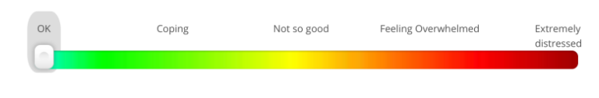
Try putting your feelings into an easy to understand categories. How am I feeling?

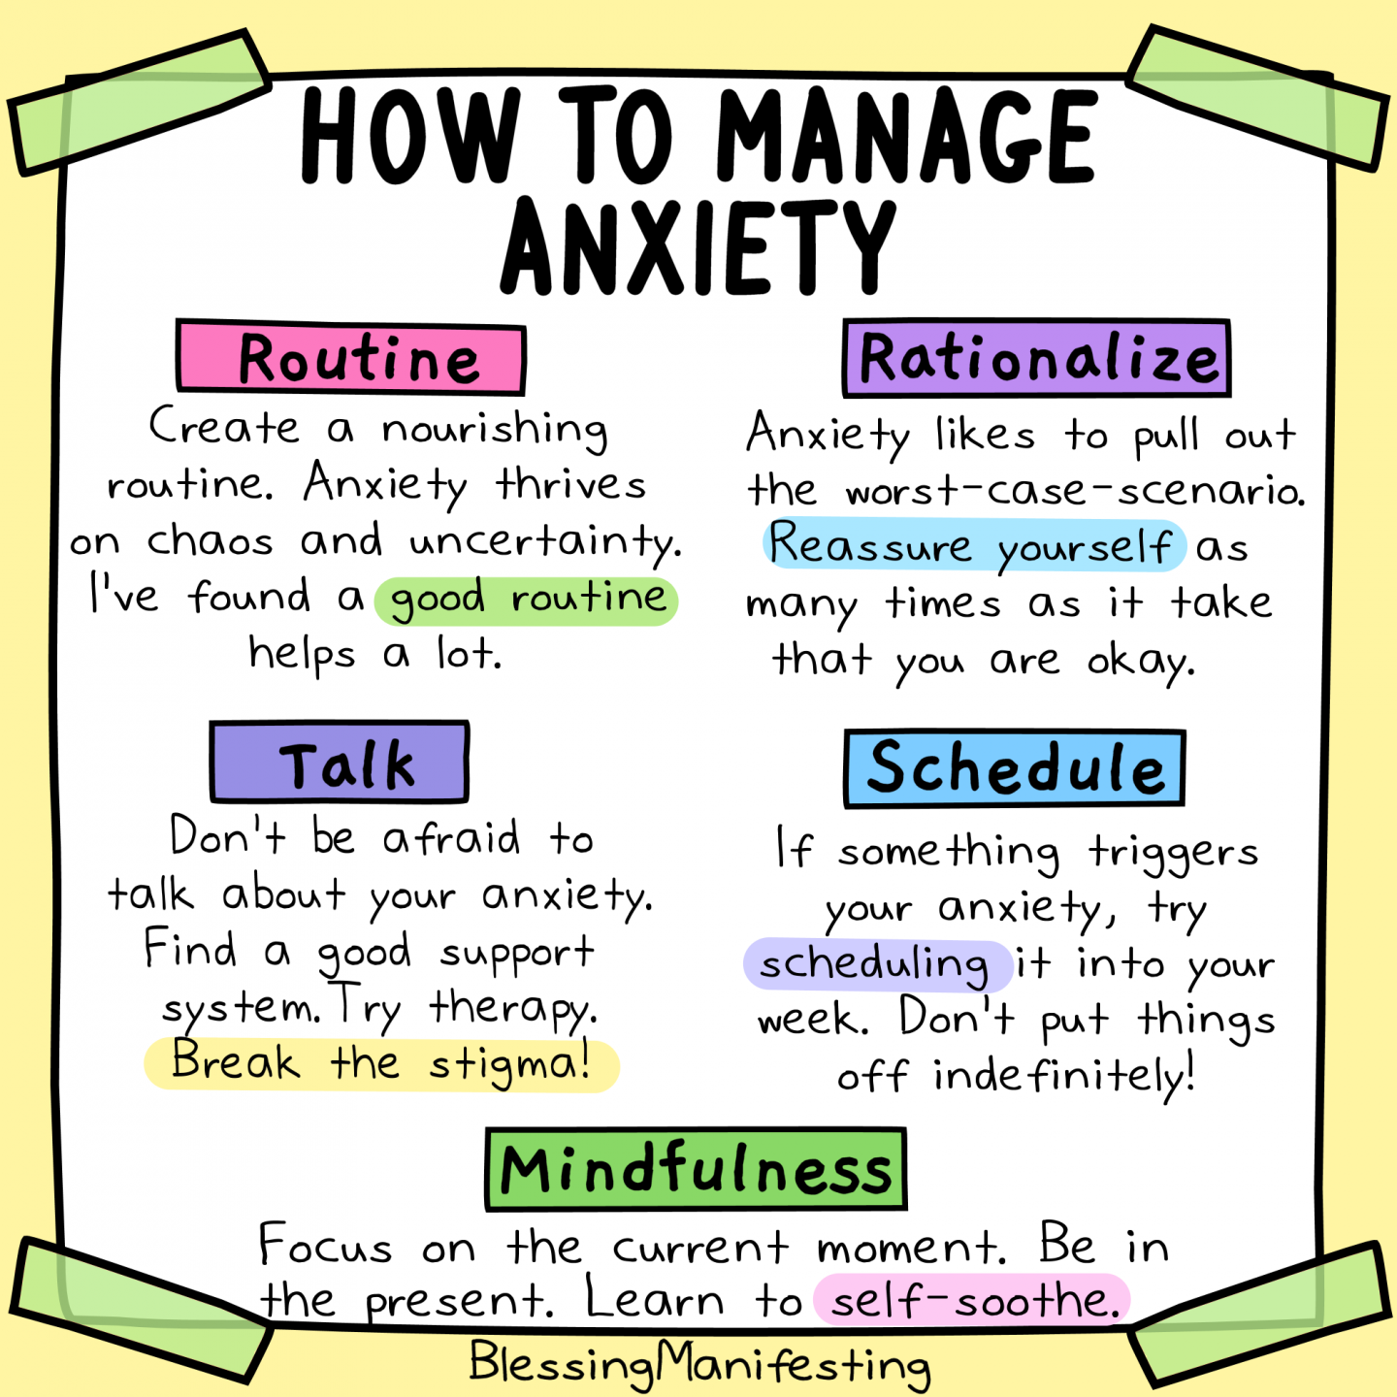
I hope that some of the tools highlighted in this guide are helpful and benefit you during your transition. Please always try to remember that you are not alone, there are lots of people to help and support you. Everyone wants to the best for you and we will all do everything we can to ensure you feel supported and confident as you move through this difficult time.
We all look forward to welcoming you back to school in September for a new school year, enjoy your summer and try to use some of the ideas in this Guide to help you feel more relaxed about your future.

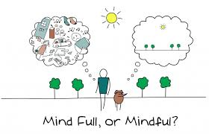

Coronavirus and looking after your mental wellbeing
It’s really important for people who are self-isolating because of coronavirus to look after their mental health and wellbeing as well their physical health.
Staying at home and avoiding contact with others as much as possible is essential to limit the risk of catching the virus or spreading it to others.
But for many people, especially if you live alone, social isolation can be a lonely, anxious, scary or depressing time. This leaflet has a few simple tips to help look after our mental well-being. It’s written for people who are self-isolating, or are maybe just feeling isolated, and who don’t have access to the internet and online entertainment or ‘distraction’ options. If you can get online, you can download a copy of this information and get lots more ideas at learn.4mentalhealth.com/wellbeing

The 30-3-30 approach
The suggestions below are grouped into things that take about 30 seconds, things that you can do in about 3 minutes, and things that might take 30 minutes or longer. The 30 second ones are quick fix ‘emergency’ actions you can do if you suddenly feel panicky, scared or unable to cope.
4 Mental Health. 2020
30 seconds | 3 minutes | 30 minutes
Take a few slow deep breaths. Breathe in, count to 3, breathe out, count to 3. | Phone a loved one or friend for a quick chat. Leave a message if they don’t answer. | Pamper yourself with a luxurious bath, and maybe have scented candles and soothing music.
Close your eyes, hold one hand in the other, squeeze gently and repeat ‘I can get through this’. | Do a household task, like a quick bit of washing up, cleaning the bathroom mirror or making a bed. | Do ‘proper sort-out’ of a cluttered kitchen cupboard, drawer, wardrobe or bookcase. Feel the satisfaction of having done something!
Sit on a chair and focus on the sensation of the chair pressing onto your back and bottom. | Make a hot drink in a mug and sip it slowly, feeing the warmth of the mug in both hands. | Enjoy a TV or radio programme, either a recording of an old favourite or something new.
Take a few sips of cold water, focusing on the cooling feeling as you swallow it. Even better if very cold or if you can add ice. | Quick brain workout, such as 3 minutes doing a wordsearch, crossword, sudoku. Try the ‘Alphabet Game’ choose a category, then using the alphabet in order, list as many as you can. | Do something ‘mindful’. This means just focusing on the one thing you are doing: such as bit of gardening, spending time on an indoor hobby, doing a jigsaw puzzle, listening to a recorded book.
Look out of a window or doorway. What can you see and hear? Anything new or unusual? | Listen to a favourite piece of music, something soothing or uplifting depending how you feel. | Prepare a tasty meal or snack, perhaps a new recipe, and eat it slowly, savouring every mouthful.
Pick up a special photo or object that evokes happy memories and focus on what it means to you. | Brush your teeth and brush or comb your hair. (even if you don’t really need to!) | Sing. At the top of your voice, sing all the songs you know, or just your favourites several times.
Learn a favourite, inspiring quote by heart, or keep a written version handy to read. | Write a worry list. Getting things down on paper can help stop them going around in your head.  Now tackle them one by one. | Go out for some fresh air, if it’s safe and allowed. If not, are there any indoor exercises, yoga or stretches you can do?

My Wellbeing Plan
Emergency Reboot. Most helpful strategies to use ‘anytime, anyplace, anywhere’

My 30-second activities. Choose several different activities so they’re ready for when you need them.

My 3-minute activities. Choose a range of calming, connecting, distraction and movement activities.

My daily 30-minute activity. Try to do at least one relaxing or fun thing a day, more if you can.

My weekly luxury 30-minute activity. Try to do this at least once a week or more if you can.

Looking after myself. Include different ways to help you stay healthy: sleep, diet, exercise.
People to contact if I feel overwhelmed. Include helplines and professional support if needed. Write their name, number and times you can phone them such as ‘any time’ or ‘9-5’.

